Chapter 17, Solution 66.

The schematic is shown below. The waveform is inputted using the attributes of VPULSE. In the Transient dialog box, we enter Print Step = 0.05, Final Time = 12, Center Frequency = 0.5, Output Vars = V(1) and click enable Fourier. After simulation, the output plot is shown below. The output file includes the following Fourier components.
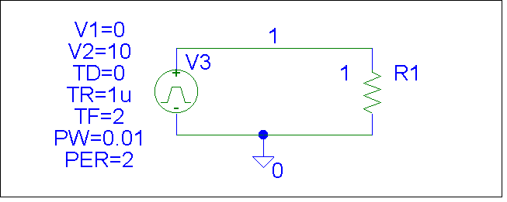

FOURIER COMPONENTS OF TRANSIENT RESPONSE V(1)

DC COMPONENT = 5.099510E+00

HARMONIC FREQUENCY FOURIER NORMALIZED PHASE NORMALIZED
NO (HZ) COMPONENT COMPONENT (DEG) PHASE (DEG)

1 5.000E-01 3.184E+00 1.000E+00 1.782E+00 0.000E+00
2 1.000E+00 1.593E+00 5.002E-01 3.564E+00 1.782E+00
3 1.500E+00 1.063E+00 3.338E-01 5.347E+00 3.564E+00
4 2.000E+00 7.978E-01 2.506E-01 7.129E+00 5.347E+00
5 2.500E+00 6.392E-01 2.008E-01 8.911E+00 7.129E+00
6 3.000E+00 5.336E-01 1.676E-01 1.069E+01 8.911E+00
7 3.500E+00 4.583E-01 1.440E-01 1.248E+01 1.069E+01
8 4.000E+00 4.020E-01 1.263E-01 1.426E+01 1.248E+01
9 4.500E+00 3.583E-01 1.126E-01 1.604E+01 1.426E+01

TOTAL HARMONIC DISTORTION = 7.363360E+01 PERCENT

From Prob. 17.4, we know the phase angle should be zero. Why do we have a phase angle equal to n(1.782)? The answer is actually quite straight forward. The angle comes from the approximation of the leading edge of the pulse. The graph shows an instantaneous rise whereas PSpice needs a finite rise time, thus artificially creating a phase shift.

